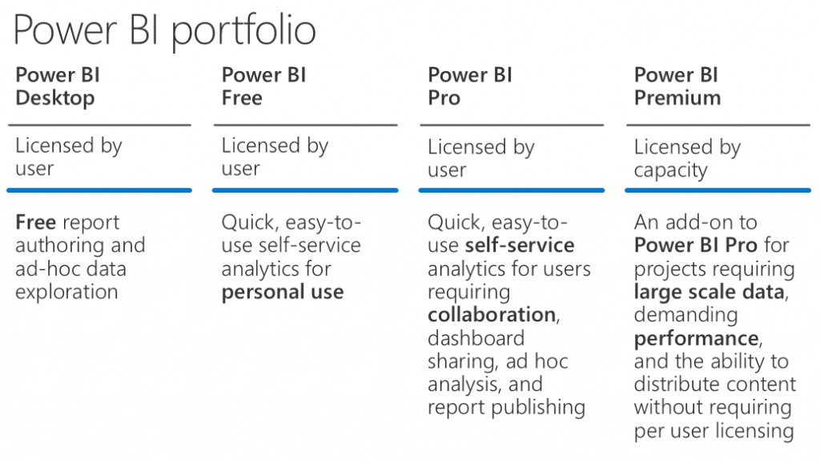

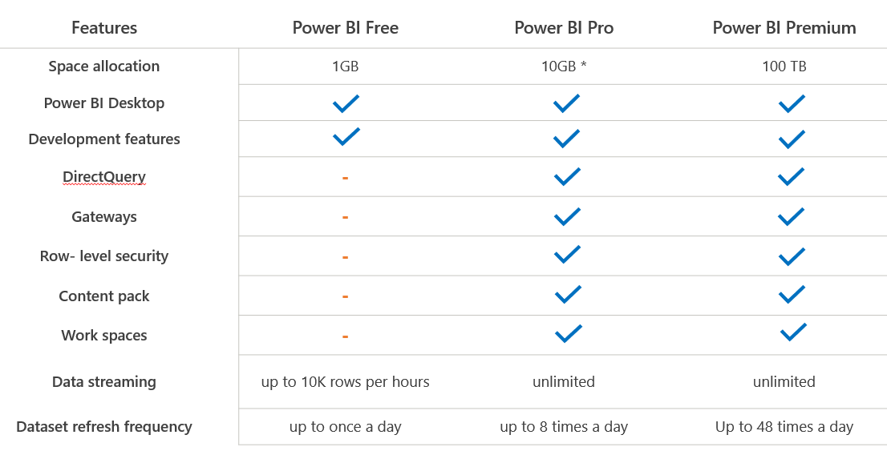

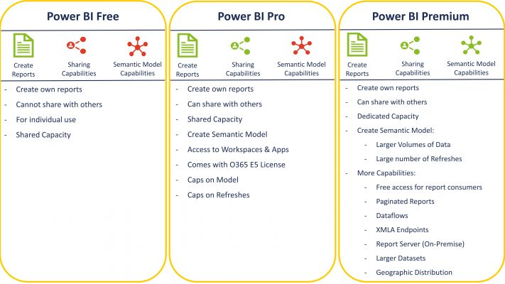

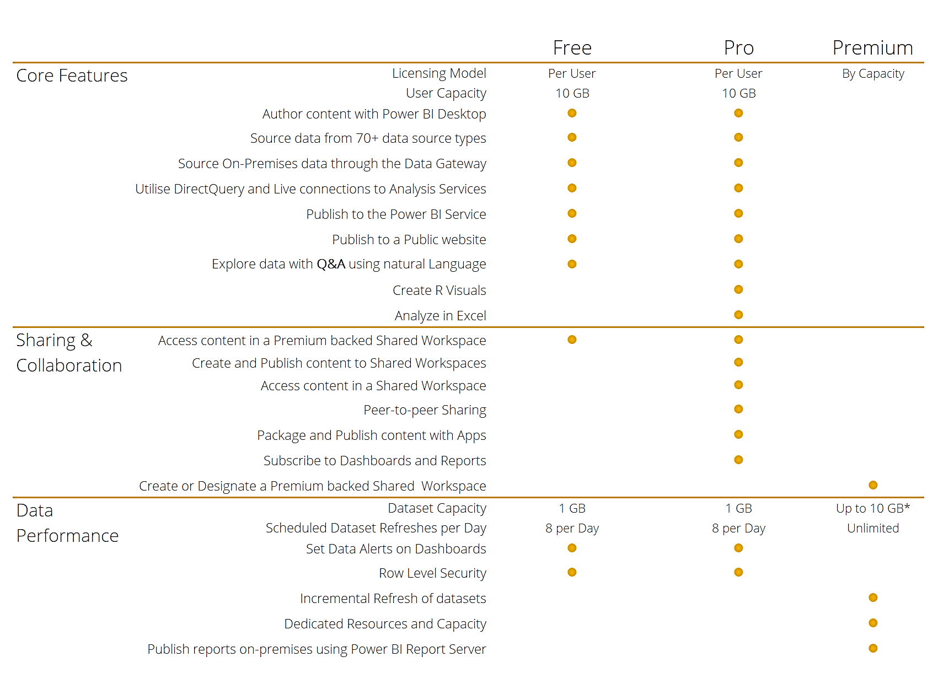

<https://adatis.co.uk/successful-enterprise-roll-out-of-power-bi-part-1/>

<https://www.cloudmoyo.com/blog/decision-analytics/a-complete-guide-to-power-bi-pricing-and-capacity-management/>